GULISTAN & TURGUT OZAL EDUCATIONAL INSTITUTIONS
INFORMATICS LESSON PLAN

DATE :
DURATION : | 40 minutes
GRADE LEVEL: | 10th Class
SUBJECT : | Formatting a Worksheet, Formatting Cells
OBJECTIVES : | To learn how to format cells

LESSON PLAN
Key words:
Materials used: | Microsoft Excel 2003 Book, Computer
Warm-up questions:

Introduction and explanation of the lesson;
THE FORMATTING TOOLBAR
The Formatting Toolbar provides quick access to commonly used formatting actions. Each action is represented by an icon. When you put your mouse pointer over an icon, it is highlighted and a descriptive tool tip appears.
The following are brief explanations of the icons on the formatting toolbar.
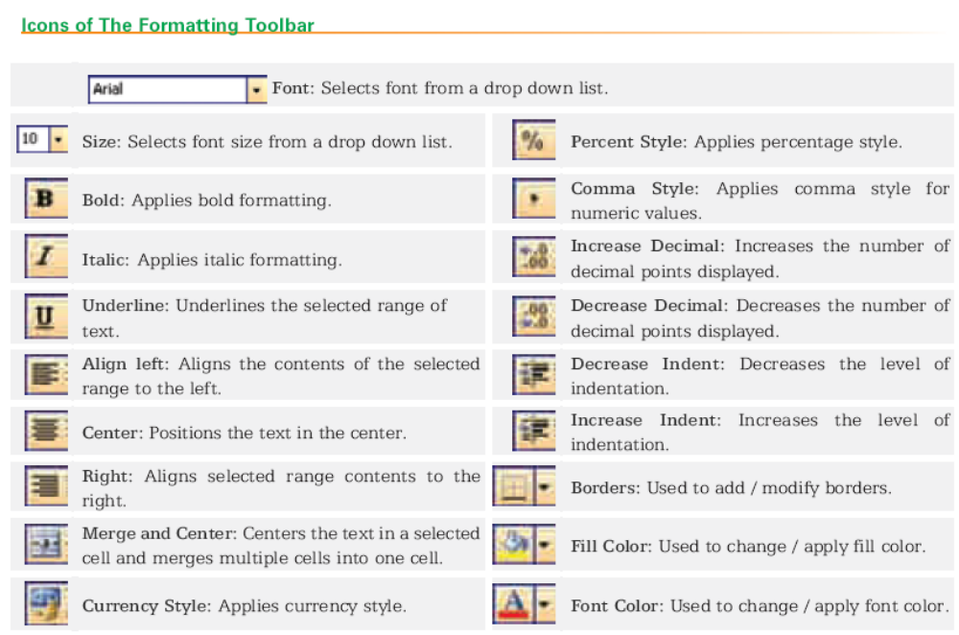

CONCLUSION:

HOMEWORK:

Teacher Director

